**A Lab Report File of**

WEB DESIGNING WORKSHOP

BCS-353

Submitted in partial fulfillment of the requirements of degree in

**BACHELOR OF TECHNOLOGY**

Submitted By

(**Mukul Kumar**-**2200821540030**)

Submitted to

**Ms. Bindu Rani**

**(**Assistant Professor)



Web designing lab [Bcs-353]

MORADABAD INSTITUTE OF TEHCNOLOGY

RAM GANGA VIHAR, PHASE-2, MORADABAD- 244001 (U.P.)

**Session:2023-2024**

**PROGRAM:-01**

Object:- Design a static webpage using html tags.

INPUT :-

<!DOCTYPE html>

<html lang="en">

<head>

<meta charset="UTF-8">

<meta name="viewport" content="width=device-width, initial-scale=1.0">

<title>My Awesome Webdesign</title>

<style>

body{

background-color: bisque;

}

.container {

text-align: center;

}

.main-content {

padding: 20px 0;

text-align: center;

}

</style>

</head>

<body>

<div class="container">

<header>

<h1>Welcome to My webdesign</h1>

</header>

</div>

<div class="main-content">

<h2>About Us</h2>

<p>Web design is the process of planning, conceptualizing, and arranging content online. It encompasses the creation of websites

and pages that are displayed on the internet. Web design includes various aspects such as web apps, mobile apps,

and user interface design. Rather than focusing on software development, web design primarily deals with

the user experience aspects of website development.</p>

<pre>

<span>There are many website builders on the market today that offer a wide range of features and services.

Wix, Squarespace, Web flow, and Page cloud, are just a few examples of popular website builders that vary in design capabilities,

template options, price, and overall editing experience. Be sure to do your research, experiment with free trials,

and determine which platform best fits your website needs. </span>

</pre>

<h1>VISUVAL ELEMENT</h1>

<ul>

<li>FONT</li>

<li>COLOR</li>

<li>SPACE</li>

<li>SHAPE</li>

</ul>

</div>

</body></html>

OUTPUT:- 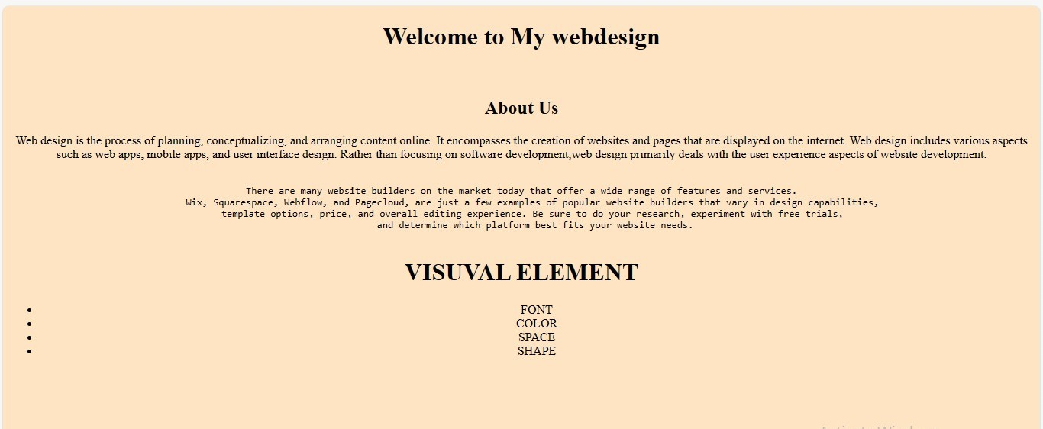

**PROGRAM:-02**

Object:- Design a student’s table using html tags.

INPUT:-

<html>

<head>

<title>my list</title>

</head>

<body>

<CENTER>

<TABLE BORDER="1" CELLPADDING="2">

<CAPTION ALIGN="Top"><b>Student Information<CAPTION>

<TR>

<TH ROWSPAN="2">S.no.</TH>

<TH ROWSPAN="2">Student name</TH>

<TH ROWSPAN="2">Date of birth</TH>

<TH Colspan="3">Marks</TH>

</TR>

<TR>

<TD>Internal</TD>

<TD>External</TD>

<TD>Total</TD>

</TR>

<TR>

<TD><center>l</TD>

<TD>AASTHA VISHNOI</TD>

<TD><center>08-02-2005</TD>

<TD><center>29</TD>

<TD><center>450</TD>

<TD><center>479</TD>

</TR>

<TR>

<TD><center>ll </TD>

<TD>SNEHA TYAGI</TD>

<TD><center>10-6-2004</TD>

<TD><center>29</TD>

<TD><center>550</TD>

<TD><center>579</TD>

</TR>

<TR>

<TD><center>III</TD>

<TD>SNEHA KUMARI</TD>

<TD><center>27-01-2004</TD>

<TD><center>29</TD>

<TD><center>565</TD>

<TD><center>594</TD>

</TR>

<TR>

<TD><center>IV </TD>

<TD>ALISHA PARVEEN</TD>

<TD><center>15-06-2005</TD>

<TD><center>29</TD>

<TD><center>565</TD>

<TD><center>594</TD>

</TR>

<TR>

<TD><center>V </TD>

<TD>ASMITA SURI</TD>

<TD><center>13-10-2005</TD>

<TD><center>28</TD>

<TD><center>501</TD>

<TD><center>529</TD>

</TR>

<TR>

<TD> <center>VI</TD>

<TD>PRAKHER KUMAR</TD>

<TD><center>04-08-2003</TD>

<TD><center>28</TD>

<TD><center>501</TD>

<TD><center>529</TD>

</TR>

<TR>

<TD> <center>VII</TD>

<TD>UTKARSH SINGH</TD>

<TD><center>14-02-2005</TD>

<TD><center>28</TD>

<TD><center>501</TD>

<TD><center>529</TD>

</TR>

<TR>

<TD> <center>VIII </TD>

<TD>MUKUL KUMAR</TD>

<TD><center>11-10-2005</TD>

<TD><center>28</TD>

<TD><center>501</TD>

<TD><center>529</TD>

</TR>

<TR>

<TD> <center>IX</TD>

<TD>VAIBHAV SAINI</TD>

<TD><center>13-12-2005</TD>

<TD><center>28</TD>

<TD><center>501</TD>

<TD><center>529</TD>

</TR>

</TABLE>

</CENTER>

</body>

</html>

OUTPUT:-

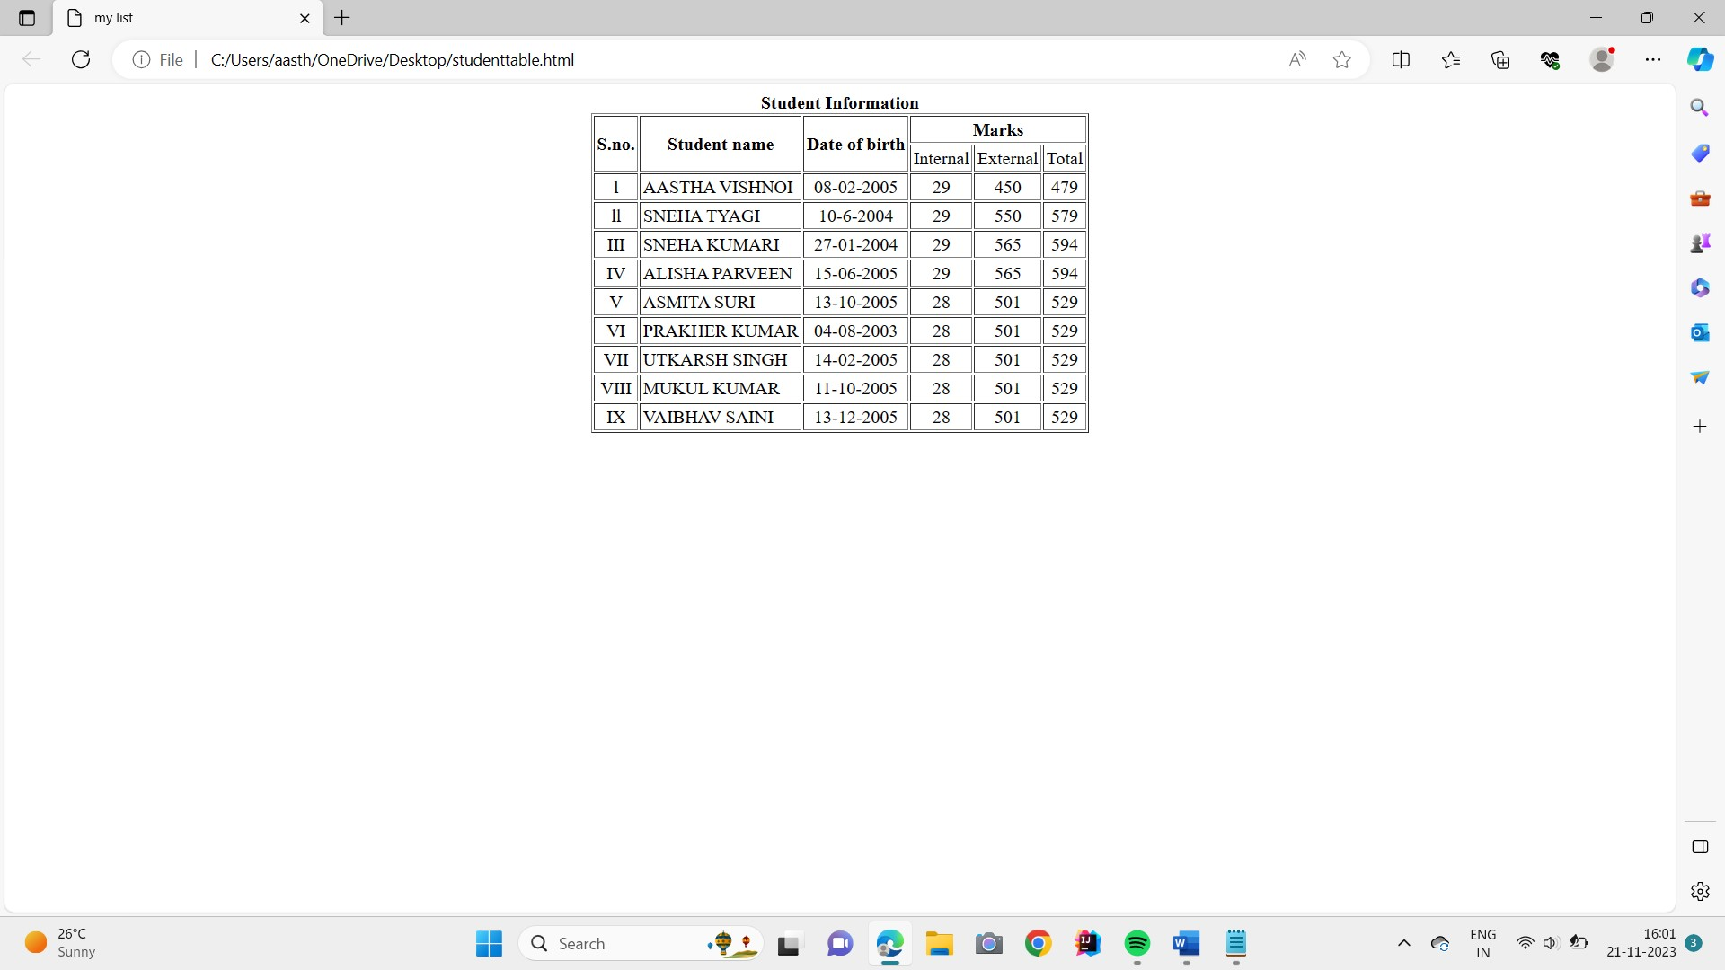

**PROGRAM:-03**

Object:- Design a static home page.

Input :-

<!DOCTYPE html>

<html lang="en">

<head>

<meta charset="UTF-8">

<meta name="viewport" content="width=device-width, initial-scale=1.0">

<title>Document</title>

<link rel="stylesheet" href="style.css">

</head>

<body>

<style>

body{

margin: 0%;

padding: 0%;

}

.head

{

display: flex;

justify-content: space-evenly;

justify-items: center;

background-color: rgb(234, 237, 240);

align-items: center;

}

.logo

{

width: 30%;

border: 1px solid black;

align-items: center;

text-align: center;

}

.logo img

{

border-radius: 30px;

}

.webname

{

width: 80%;

display: flex;

justify-content: space-evenly;

justify-items: center;

border: 1px solid black;

padding-top: 23px;

padding-bottom: 23px;

}

.info

{

display: flex;

justify-content: space-evenly;

justify-items: center;

}

.link

{

width: 20%;

display: flex;

justify-content: space-evenly;

justify-items: center;

background-color: rgb(192, 163, 241);

border: 1px solid black;

}

li ol

{

list-style: none;

text-decoration: none;

}

.home

{

display: flex;

justify-content: space-evenly;

justify-items:center;

}

.course {

width: 20%;

text-align: center;

background-color: rgb(168, 111, 94);

border: 1px solid black;

}

.link a

{

text-decoration: none;

color: black;

}

.description

{

width: 80%;

background-color: rgb(252, 229, 194);

}

</style>

<div class="header">

<div class="head">

<div class="logo">

<img src="C:\Users\aasth\OneDrive\Desktop\mit.jpeg" alt="Logo">

</div>

<div class="webname">

<h1>

Website name

</h1>

</div>

</div></div>

<div class="info">

<div class="link"><a href="Home.html">Home</a></div>

<div class="link"><a href="loginpage.html">Login</a></div>

<div class="link"><a href="Registration.html">Registration</a></div>

<div class="link"><a href="cataloguepage.html">Catalogue</a></div>

<div class="link"><a href="Cart.html">Cart</a></div>

</div>

<div class="home">

<div class="course">

<div>CSE</div>

<div>ECE</div>

<div>EEE</div>

<div>CIVIL</div>

</div>

<div class="description">

</div>

</div>

</body>

</html>

Output:-

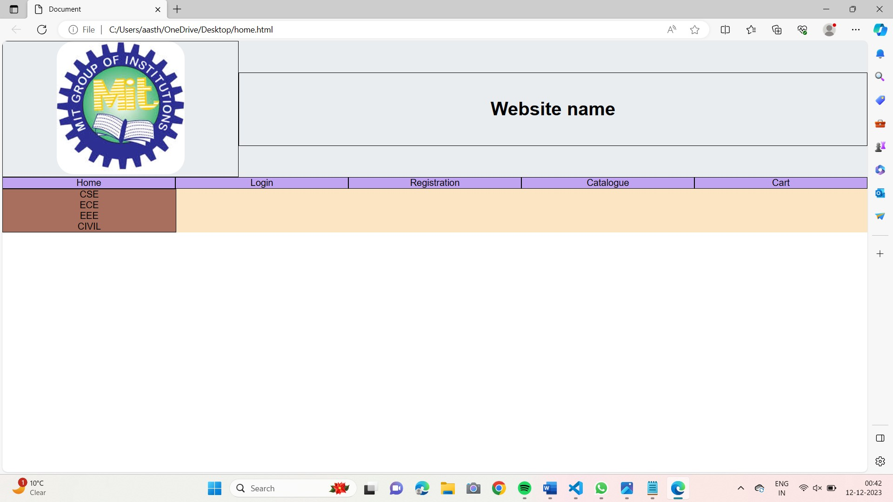

PROGRAM:-04

Object:- Design a login page using html and css.

INPUT HTML:

<!DOCTYPE html>

<html>

<head>

<title>Login Page</title>

<style>

body {

font-family: Arial, sans-serif;

}

.container {

width: 300px;

padding: 16px;

background-color: white;

margin: 0 auto;

margin-top: 100px;

border: 1px solid black;

border-radius: 4px;

}

.container input[type=text], .container input[type=password] {

width: 100%;

padding: 15px;

margin: 5px 0 22px 0;

border: none;

background: #f1f1f1;

}

.container input[type=submit] {

background-color: #4CAF50;

color: white;

padding: 14px 20px;

margin: 8px 0;

border: none;

cursor: pointer;

width: 100%;

}

.container input[type=submit]:hover {

opacity: 0.8;

}

</style>

</head>

<body>

<div class="container">

<label for="username"><b>Username</b></label>

<input type="text" placeholder="Enter Username" name="username" required>

<label for="password"><b>Password</b></label>

<input type="password" placeholder="Enter Password" name="password" required>

<input type="submit" value="Login">

</div>

</body>

</html>

OUTPUT:-

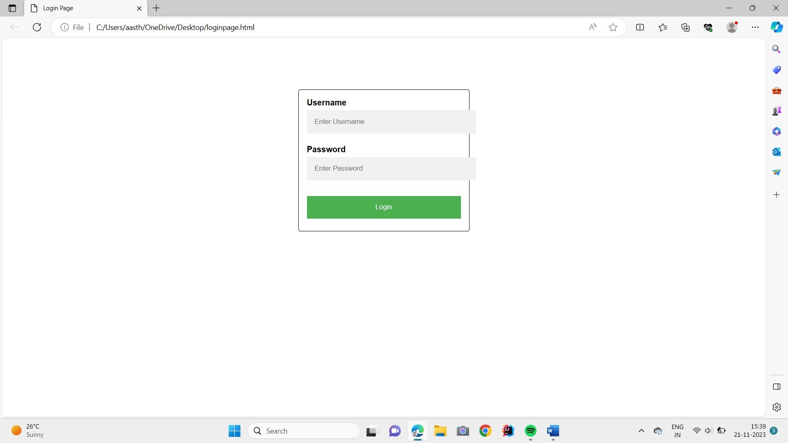

**PROGRAM:-05**

Object:- Design a Registration page using html and css.

INPUT HTML:-

<!DOCTYPE html>

<html lang="en">

<head>

<meta charset="UTF-8">

<meta name="viewport" content="width=device-width, initial-scale=1.0">

<title>Registration Form</title>

</head>

<style>

body{

background-color: bisque;

}

.form-item{

text-align: center;

margin: 5%;

}

.registration-form{

text-align: center;

padding: 30px;

border-radius: 0%;

box-shadow: 0 0 10px rgba(0, 0,0,0.1);width:650px;

margin:30px auto;

background: linear-gradient (to right, #ffffff 0%, #fafafa 50%, #ffffff 99%);

border-radius: 10px;

}

</style>

<body>

<form class="registration-form">

<h2>Registration Form</h2>

<div class="form-item">

<label for="first Name">First Name:</label>

<input type="text" id="first Name" name="first Name" required>

</div>

<div class="form-item">

<label for="last Name">Last Name:</label>

<input type="text" id="last Name" name="last Name" required>

</div>

<div class="form-item">

<label for="email">Email:</label>

<input type="email" id="email" name="email" required>

</div>

<div class="form-item">

<label for="phone Number">Phone Number:</label>

<input type="tel" id="phone Number" name="phone Number" required>

</div>

<div class="form-item">

<label for="password">Password:</label>

<input type="password" id="password" name="password" required>

</div>

<div class="form-item">

<label for="confirm Password">Confirm Password:</label>

<input type="password" id="confirm Password" name="confirm Password" required>

</div>

<div class="form-item">

<label for="gender">Gender:</label>

<select id="gender" name="gender" required>

<option value="male">Male</option>

<option value="female">Female</option>

<option value="other">Other</option>

</select>

OUTPUT:-

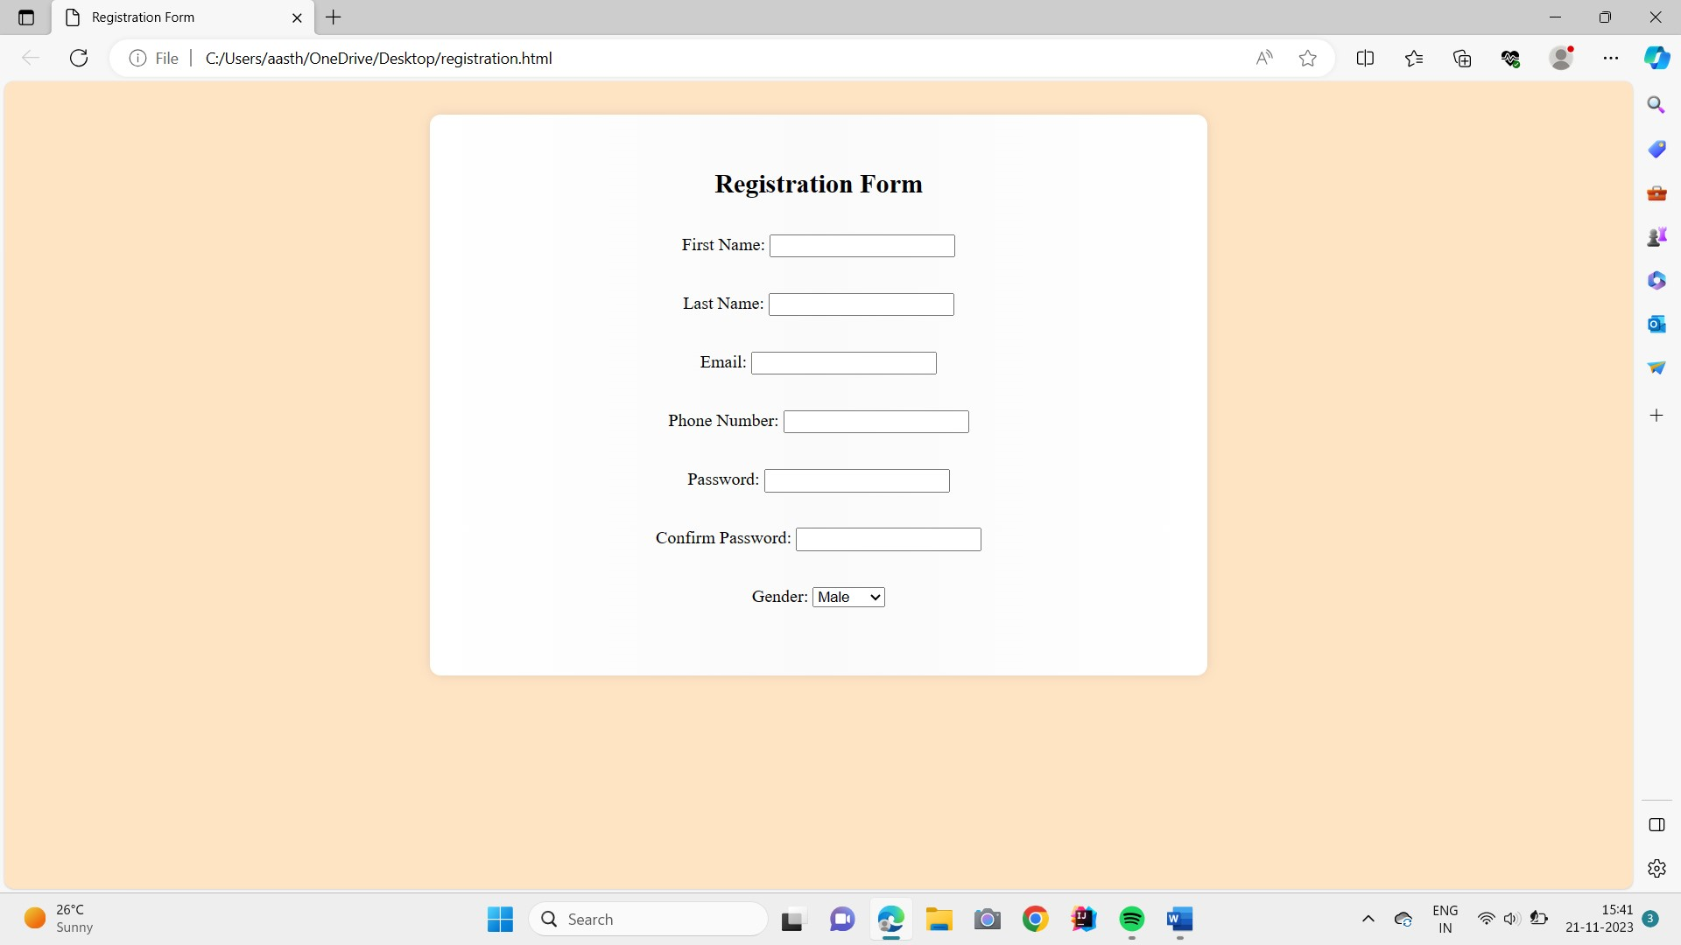

**PROGRAM:-06**

Object:- Design a catalogue page using html and css.

INPUT HTML:-

<!DOCTYPE html>

<html>

<head>

<meta charset="utf-8">

<meta name="viewport" content="width=device-width, initial-scale=1">

</head>

<body>

<center>

<form>

<table cellspacing="10" border="1">

<tr>

<td><img src="C:\Users\Admin\Desktop\book1.jpg" width="100" height="100"></td>

<td> Title : HTML5 and CSS3 <br>

Author : Sasha Vodnik&nbsp; &nbsp;<br> </td>

<td>Rs. 700 /- </td>

<td><button type="button" class="btn btn-outline-success">Add to cart</button></td>

</tr>

<tr>

<td><img src="C:\Users\Admin\Desktop\download.jpeg" width="100" height="100"></td>

<td> Title : PHP and MYSQL <br>

Author : W. Jason Gilmore&nbsp; &nbsp;<br> </td>

<td>Rs. 650 /- </td>

<td><button type="button" class="btn btn-outline-success">Add to cart</button></td>

</tr>

<tr>

<td><img src="C:\Users\Admin\Desktop\download 2.png" width="100" height="100"></td>

<td> Title : The Complete Reference JAVA 2 <br>

Author : Herbert Schildt &nbsp; &nbsp;<br> </td>

<td>Rs. 850 /- </td>

<td><button type="button" class="btn btn-outline-success">Add to cart</button></td>

</tr>

</table>

</form>

</center>

</body>

</html>